Security Clearance question for Charles or filling later:

1 Name is different in driving license vs passport (that should be fine or do I need to change in driving license)? – Passport will be the primary
2 What is the best way to provide the supervisor name for every employment record? – name phone and address – HR email (I do not know)
3. I had a rental property with my name on the loan and deed as a partnership. (Not my residence). Do I need to provide that information? – Name of Defendant -
4. Named Swati Chokshi – During unemployment Spouse – Is that fine? Or who should I put?- Spouce Name will be fine
5. During the previous Employment – I do not have contact information of supervisor or friends – They have either retired, moved, or not working in those position. So I am not sure who do put. Will the HR information should be good enough? -
5.1 – If I know the supervisor but it was only for few years as he has moved out of the company (is this fine as a partial information)
5.2 – I have provided Jason Rich current phone number and email address rather than PRA. Is that correct?
5.2 Hampton Uinversity Supervisor I am not sure about his wareabouts
5.2 Arvon staffing – It was for very short time (less than 4 weeks) so I am not sure about my exact location of the office and supervisor name. I was through Staffing company, I have provide that information.
5.3 I was unemployed and getting pay from Virginia employment commission do I need to report or unemployed is sufficient enough? – Unemployment is fine -
5.4 Kokilaben address needs to fix.
6 Foreign Association . Only provided monther’s name as father is deceased.
Friends - Spouces Family members – Continuing -

7. FINANCial record – I had a property and deed as a partnership. That was sold in around 3 years back. I had to file a law suit against the partner and won the judgement before the property was transferred to my name. – Sending money to india – before citizenship

I used to send money to my parent long time back. After I have received the US citizenship, I have not sent money to them. And this is best of my memory. Unfortunately, I do not possess or remember exact transaction records.
8. Same goes for offences –

9. Traffic ticket was issued around 2008 not sure about the month and year. I had to go through the school to boost my points with paying fine. – Court Records – Virginia Beach Training – I did not find any thing on the virginia beach circuit court.
10. Sent the information to Jason and Drew
11. SSS – services questions. I am not aware of it. – Talk on Mondya – If I registered – Not

Section 9 – Citizen ship – from the Draft copy –
- Data of Entry and location – Is this my last entry to USA or the First Entry when I entered in USA with Indian Passport.
- NBIS Portal – What is it and Do I need to set up an access? – This is accessible though Dashboard at https://eapp.icam.dcsa.mil/
- What are the unintended information that may have gone rejection
  - If it is rejected, is there a way to appeal? Or mitigate some trivial information as a second chance?
- My mom and Mother in-law is receiving a pension and worked for the state government as an administrative/teaching position. Does that cause of a concern?
- During year 1999 – I have moved my apartment and may have not received the statements to the new location and I had no idea that I have not paid the card. The account was charge off in year 2003. It was form Old Navy. And for 70 dollars.I belive that was fully paid in few years (not sure about the timing). The credit report does not show the late payment. Do I need to report and how? It says last 7 years –

- 200

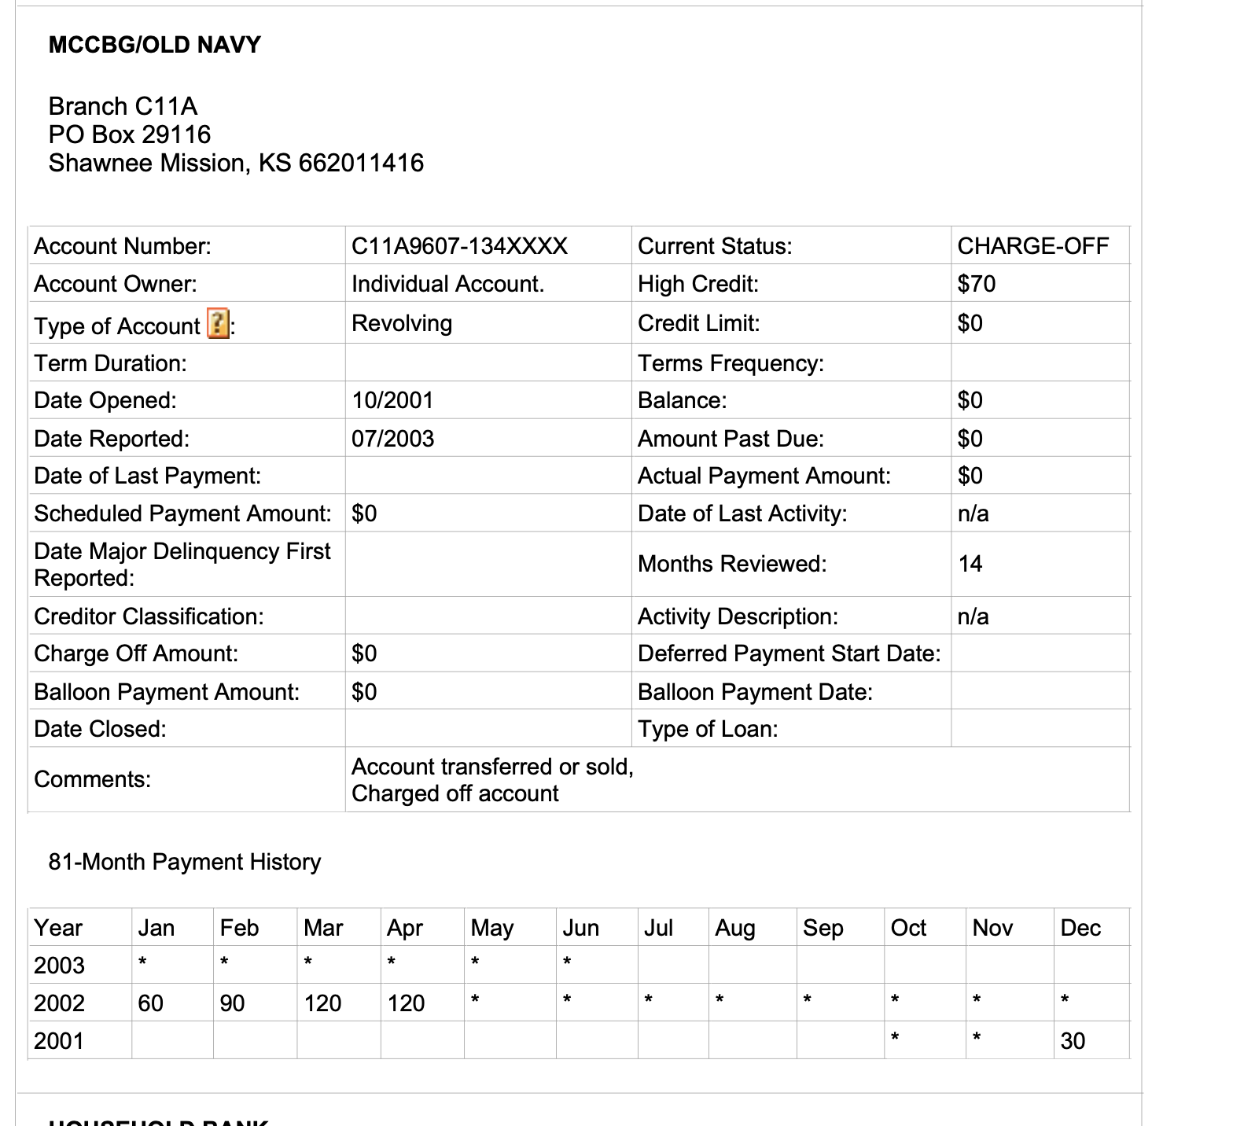

First Name
Middle name
Last name
Provide the approximate date of first contact
Provide the approximate date of last contact
Provide methods of contact
Provide approximate frequency of contact
Provide the nature of relationship
Has this foreign national used any other names and/or nicknames?
Provide this foreign national's place of birth
Provide this foreign national's current address
Provide the address of the foreign national's current employer, or provide the address of their most recent employer if not currently employed (There is an option I donot know)

